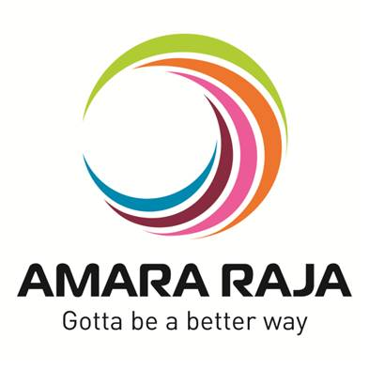

TPM-Trak®

**Industry 4.0 & IoT solutions**

# Student Name : VISHVAJIT S

# ROLL NO : CBENU4CSE19262

# College : Amrita Vishwa Vidyapeetham, Coimbatore, Tamil Nadu

# Phone. No : 6383598421

# Training : Oct 04- Nov 04

# Department : Information Technology [IT],

# Company : Amara Raja group of company’s

# Working Branch : Mangal Industries Ltd.

# AMARA RAJA GROUP OF COMPANIES

# Tirupati-517520



# CERTIFICATE

# This is to certify that the project report entitled “TPM Track Industry 4.0 & IoT solutions” that is submitted by VISHVAJIT S_ bearing TPM Track Industry 4.0 & IoT solutions in partial fulfillment of the requirement for the award of the “industrial training certificate” is bonafied work carried out by him during 5th semester of the 4 years’ B.Tech course 2019-2021 at AMARA RAJA GROUP OF COMPANIES Ltd.

**Head Guide**

**Examiner**

**PREFACE**

**The Need for Engineers to meet the demand for countries development Plans is well recognized. Complement and qualified Engineers are not really available for field work, Industry, R&D and Teaching. The Projection made on this demand is huge and the gap between the supply and demand is large. For the accelerated development, the country requires a large number of graduate and diploma engineers to be produced and trained. To meet this requirement, the government encouraged the establishment of new engineering colleges and Polytechnics in public and private sectors. Lakhs of graduate and diploma engineering students are passing out of institutions. But the performance of the students in interviews they face for placements, the feedback from many of the industries is highly discouraging.**

**In view of this, a strategic frame work in the state of Andhra Pradesh has been introduced by the department of Technical Education for importing industrial training to all the final year Diploma Students, which has become a mandatory.**

**The industrial training in industry will fill the gap between industry and institute and develops the supervisory skills, administrative skills and Technical skill levels of the student and make the student to face the demand of the industry, when they attend the interviews.**

**In fact, the industrial training will cover the gap in the hand on skill of the student and makes the student suitable to industry needs.**

# INTRODUCTION TO AMARA RAJA

### VISION

**To transform our spheres of influence and to improve the quality of life by building institutions that provide better opportunities, goods and services to more people……All the time.**

# ACHIVEMENTS OF AMARA RAJA

**ISO 14001 in 2002**

**5S, Six-sigma & SITG awards & Recognitions**

* **Industrial economist Business Excellence Award-1991 by the Industrial Economist, Chennai.**
* **Best entrepreneur of the year 1998-by Hyderabad Management Association.**
* **Excellence award by institution of economic studies, New Delhi.**
* **Udyog Rattan-1999 by institution of Economic Studies, New Delhi.**
* **Automotive Product of The year 2000 by overdrive.**
* **Excellence in Environmental management in 2012 by Govt. of AP. Q1Vendor Status by Ford India Ltd-2013**
* **World Excellence Silver Award by Ford-USA.**
* **ARBL Engineering nominated For JCI Chairman’s Award in 2004 for vent plug Design.**
* **ARBL Engineering & Marketing Staff nominated for JCI Chairman’s Award in 2005 for yellow hat.**
* **And Some honors of state and union governments**

**Amara Raja Batteries Private Limited (ARBL) Company incorporated under the Company’s Act 1956 in 13 February 1985, and converted into Public limited company on 6th September 1990.**

**The technocrat entrepreneur Sri Rama Chandra Naidu Galla is the chairman and managing director of the company .Amara Raja Batteries Limited is the first company in India Which Manufactures value regulated Lead Acid (VRLA) Batteries. The main Objectives of the company is manufacturing of good quality of ‘sealed maintenance Free (SMF)’ acid Batteries. The company is setting up to Rs 1920 Plant is in 18 acres area in Karakambadi Village, ReniguntaMandal. The project site is notified under ‘B’ category.**

**The company has the clear cut policy of direct selling without any intermediate. So they have set up 6 branches and are operated by corporate operations office located in Chennai. The company has virtual monopoly in higher A.H (Amp Hour) Rating Market its product VRLA. It is also having the facility for industrial and automotive batteries.**

**Mr. Galla Ramachandra Naidu Chairman who an NRI is having Engineering background promoted Amara Raja Batteries Limited in 1985 at Karakambadi Village near Tirupati. He also seeded**

**Harsha Electronics Limited In 1990 at Karakambadi Village near chittoor and Amara Raja Electronics In 2000 at Diguvamagam Village near Chittoor before Embarking on this venture he worked as senior project engineer with M/s Sergeant and Lundy, USA (Power consultants) for about 20 years. Prior to this, He Worked as an engineer for US steel corporation for about 3 years.**

**In 1989, ARBL has entered into Industrial Battery market with Technical Alliance with GNB Batteries, USA to Promote Advanced Maintenance Free Value Regulated Lead Acid (MF – VRLA) Batteries Prior to setting its own facilities ARBCL imported the product in semi- knocked down condition. In September 1990, it was corrected in to a public limited company and its IPO (Initial Public offer) in January 1991 aggregating Rs 59.5 million. It was formed to manufacture maintenance free sealed Lead Acid batteries in which commercial production commenced from May 1992.**

**Despite it in technical support from GNB batteries during the finished gear 1998 ARBL ceded a 23.7% stake to Johnson controls INC.USA, of a permission of Rs 75 per share to cement a financial and technical tie up to foray into automotive batteries besides overall control of the company as the chairman Mr. Rama Chandra Naidu Galla and his son, Mr. Jayadev Galla, Who is acting as Managing director of the company, has worked entire with GNB batteries technologies, USA as an INTERNATIONAL sales executing.**

# ****GROUP VISION 2025****

**We will be a top 500 Global Group, redefining businesses to deliver high social impact, by Anticipating future trends , Building preferred brands and leveraging talent and Technology.**

# ****ABOUT AMARARAJA****

**Amara Raja believes in influencing and improving the quality of life by building institutions that provide better access to opportunities, goods and services to people all the time.**

**With innovative engineering research and design, Amara Raja has grown with partnership and information sharing with world leaders. Amara Raja committed towards latest generation technologies by developing and manufacturing globally competitive, customer focused products of world class quality and responsibility introducing these products into relevant markets.**

# ****Amara Raja Group of Companies: -****

|  |  |  |
| --- | --- | --- |
| **Sl. No.** | **Group of Companies** | **Location** |
| **1** | **Amara Raja Power systems Ltd.** | **Karakambadi** |
| **2** | **Mangal industries limited** | **Karakambadi** |
| **3** | **Amara Raja Batteries Ltd.** | **Karakambadi** |
| **4** | **Amara Raja Infra Pvt Ltd.** | **Karakambadi** |
| **5** | **Amara Raja Industrial Services Pvt Ltd.** | **Karakambadi** |
| **6** | **Mangal industries limited** | **Petamitta** |
| **7** | **Galla Foods Pvt Ltd.** | **Petamitta** |
| **8** | **Amara Raja Electronics Ltd.** | **Diguvamagam** |

# ****Values:****

**The values of an organization reveal its soul. Just like an individual’s soul in unique and difference from that of the others, so are the values of an organization. Values are the foundation on which we build the organization.**

**The five Core Value embodied in the culture of the Amara Raja Groups are:**

1. **Innovation**
2. **Excellence**
3. **Entrepreneurship**
4. **Experiences**
5. **Responsibility**

**Group of Companies:**

1. **Amara Raja Batteries Ltd: Manufactures industrial and automotive batteries.**
2. **Amara Raja Power System (P) Ltd: Design and development of Power electronic products, Power electronics system integration and testing, magnetic manufacturing**
3. **Man gal Industries Ltd: Fabrication of advanced sheet metal products and fasteners, plastic component and compounds.**
4. **Amara Raja Electronics Ltd: PCB Assembly, Electronic Products Assembly and Testing and manufacturing of Battery Charges, Digital invertors and trickle chargers.**
5. **Amara Raja Infra (P) Ltd, Karakambadi : Infra and Civil constructions**
6. **Amara Raja Industrial Services (P) Ltd., Karakambadi : Facility Management and other Industrial Services**

**Table of Contents**

1. LIST OF MACHINES AND HARDWARE UNDER CONSIDERATION
2. SOLUTION METHODOLOGY
3. SOLUTION OVERVIEW
4. SOLUTION TOPOLOGY (SAMPLE)
5. *TPM-Trak help requests*
6. *Tool Life.*
7. *Error! Bookmark not defined.*
8. HARDWARE SCOPE OF SUPPLY (CORE TPM-TRAK HARDWARE)
9. SOFTWARE SCOPE OF SUPPLY
10. SAMPLE DASHBOARDS, REPORTS.

**LIST OF MACHINES AND HARDWARE UNDER CONSIDERATION**

|  |  |  |  |
| --- | --- | --- | --- |
| Sl. No. | Machines | Quantity | Hardware |
| 1 | Turret Punch Press | 4 | TCS_PLC |
| 2 | Laser Cutting | 2 | TCS_PLC |
| 3 | Press Brake | 8 | TCS_PLC |
| 4 | Power Press | 6 | TCS_PLC |
| 5 | Robot Welding | 2 | TCS_PLC |

**SOLUTION METHODOLOGY**

Each machine/asset that is capable of providing signals to represent different events of interest will be interfaced with a TCS_PLC hardware that comprises a 5.7” Touch Screen HMI and a PLC.

TCS_PLC hardware will collect the data from the machine automatically based on the signal interfaced to the machine, no manual intervention is required for quantification of cycle time or down time (durations).

Typical Operator interactions would be as follows:

• Keying in his/her ID at the beginning of the shift

• Qualifying a Down time with a “reason “ (timing will be automatically calculated)

• Providing correct component ID & Operation ID

For assets that do not provide automated signals, we may have to enable manual data entry via 5.7” HMIs.

All the data acquired will go into a central MS SQL Database.

The following data and workflows will be captured to arrive at the OEE of the machine/asset:

1. Machine ID

2. Running Part ID / Component ID

3. Operation number

4. Operator ID

5. Cycle Start

6. Cycle complete

7. In-process stoppage indicator such as Spindle Stop (if applicable)

8. Machine Stoppage outside of a Cycle

9. Reason for stoppage

10. Rejection Log at the machine (if required).

11. Help request- Manually generated alert from HMI.

**Solution Overview**

1. Key pieces of information required to be identified are Machine, Part

(Component), Operation and Operator.

2. These pieces of information mentioned in 1 are provided to the system via the HMI.

3. All these ids mentioned above, should have corresponding master information defined in TPM-Trak.

4. It is Operator's responsibility to provide his id at the beginning of the shift.

5. Cycle Start, Spindle ON/OFF, Auto Mode, Cycle End is recorded in the TPM-Trak PLC from the machines.

6. If the Machine stops beyond a certain threshold time (can be configured for each machine), the CYCLE Start button will be interlocked and the Operator is forced to provide a reason.

7. In TPM-Trak, downtimes are recorded at the end of the downtime (along with the reason)

8. Once the down time has been qualified, then TPM-Trak PLC will notify the machine PLC to remove the interlock at the machine.

9. There will be a provision for the operator to provide Rejection data via the HMI

10. Few reports can be scheduled for auto-generation and emailing for a pre-defined set of users

**SOLUTION TOPOLOGY (SAMPLE)**

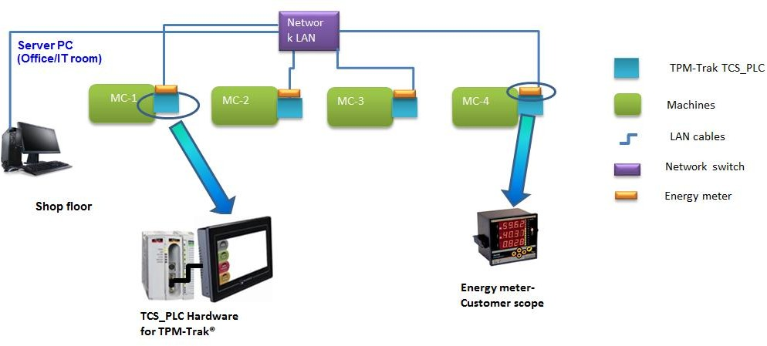

**Important to Note:**

* Topology shown above is only a pictorial representation of a typical installation (not as per lay out).
* All IT hardware components shown above are customer scope except TCS_PLC.
* The TCS_PLC comprises of controller as well as touch screen HMI.

**TPM-Trak help requests**

This feature will allow the machine operator to raise help request for 4 departments, such as Maintenance, Production, Stores/Tooling and Supervisor.

* The Help requests are generated thru 5.7” touch HMI deployed at the machine as shown in earlier pages.
* The Events generated in HMI are passed to the server and processed in TPM-Trak.
* The SMS messages are generated through TPM-Trak software from server.
* SMS Distribution: It is recommended to subscribe to Internet-based SMS distribution service; the service provider will provide credentials using which TPM-Trak software can broadcast the SMS. This SMS subscription is out of scope for this proposal.
* Any non-availability/breakdown of IT infrastructure (Network / Switches) will affect the real-time SMS distribution.
* Workflow:
* The operator will raise the request thru HMI (the request will be logged in the software)
* The concerned person will get an SMS/Email.
* He will rush to the machine and acknowledge the problem (the action will be logged)
* He will solve the problem and complete the help request (the action will be logged)

**Help request screen (HMI)**



i) Configuring TCS_PLC

ii) Software module to handle help request and subsequent alerts.

iii) Installation and training.

**Sample report for Help requests:**

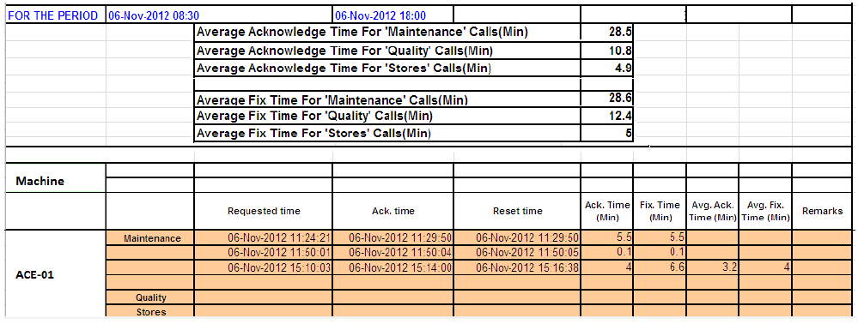

**HARDWARE SCOPE OF SUPPLY (CORE TPM-TRAK HARDWARE)**

|  |  |  |  |
| --- | --- | --- | --- |
| Sl. No. | Machines | Quantity | Hardware |
| 1 | Turret Punch Press | 4 | TCS_PLC |
| 2 | Laser Cutting | 2 | TCS_PLC |
| 3 | Press Brake | 8 | TCS_PLC |
| 4 | Power Press | 6 | TCS_PLC |
| 5 | Robot Welding | 2 | TCS_PLC |

TCS_PLC is TPM-Trak control system with 5.7 Inch Touch Screen.

Enclosure mount the HMI also will be provided.

One 4 Channel relay board will be supplied along with each TCS_PLC

**Total Quantity of TCS_PLC kits – 22 numbers**

It is assumed that the devices supplied will connect to *your* central data collection server/PC using Ethernet LAN infrastructure. IT, LAN Network and Power infrastructure are out of scope of our supply.

*Our liability is limited to our scope of supply items only. No other liabilities are accepted.*

***Software Scope of supply***

It is recommended that a licensed edition of MS SQL 2012/2014 Standard should be deployed by ABI SHOWATECH. Software will be compatible with Windows 7, Windows 8.1, windows 10 and Server 2012 *o*nly.

|  |  |  |  |
| --- | --- | --- | --- |
| **Product Name, version** | **Description** | | **Used for** |
| **TPM-Trak ver. 5.10, Windows Client / Server version** | | **TPM-Trak Consists of the following modules/features.** | |
| **Smart Shop** | | Master data management | |
| **Admin** | | Data management module with admin features | |
| **Smart Data** | | Data collection module | |
| **Cockpit and View Data Graph** | | Data viewing and analysis | |
| **Smart Manager** | | Reporting module with standard and aggregated reports | |
| **Add-on** | **Auto Email of reports** | | Few identified reports will be auto generated and emailed to a pre-defined set of users |
| Add-on | **Smart Alerts** | | SMS alerts for Machine Down times |
| **Add-on** | **Visual ANDON** | | Shop ANDONs designed to run on MS Windows connected to TVs |
| **Add-on** | **Tool Life** | | Tool life monitoring based on Tool ID |
| **Add-on** | **Help Request Module** | | Help request alerting and logging software. |
| **Add-on** | **e-SHOPx** | | View Drawings, process sheets, setup instructions etc. for all the machines in the cell. A cell PC is required for installing the software. |
| **SAMPLE DASHBOARDS, REPORTS.**  Screens below represent the core framework of our Industry 4.0 products.    3 | | | |

##### **TV-ANDON Screens- Sample**

###### **Machine view**

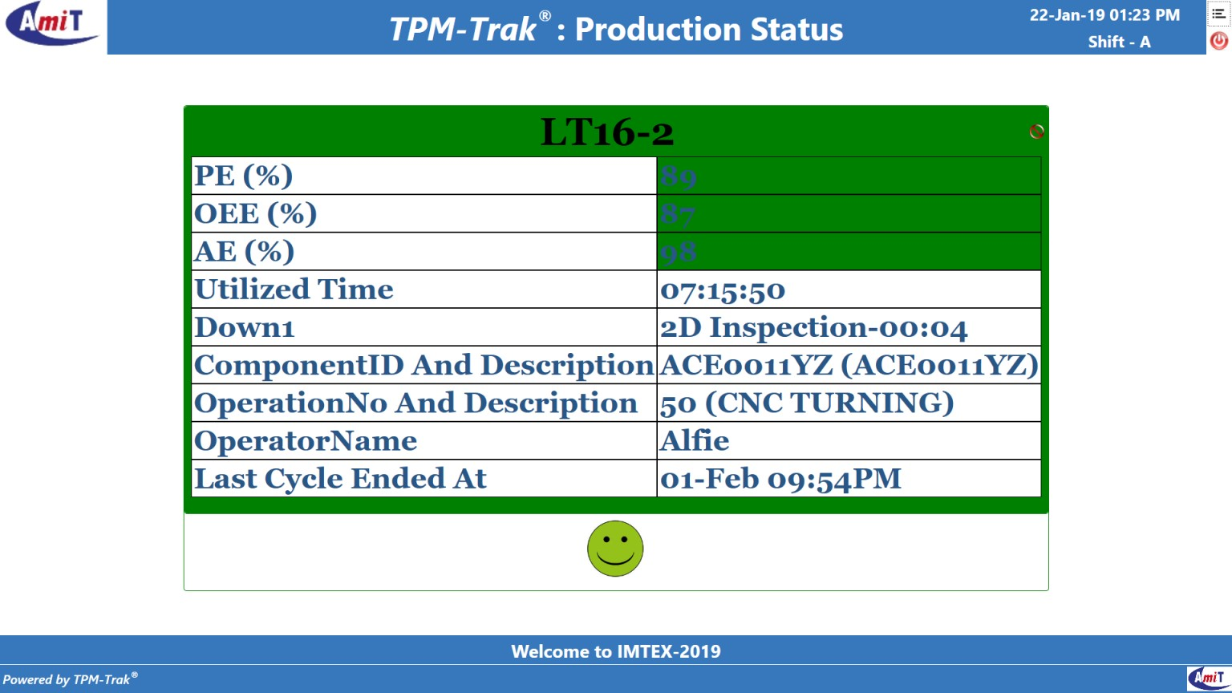

**Shop View**

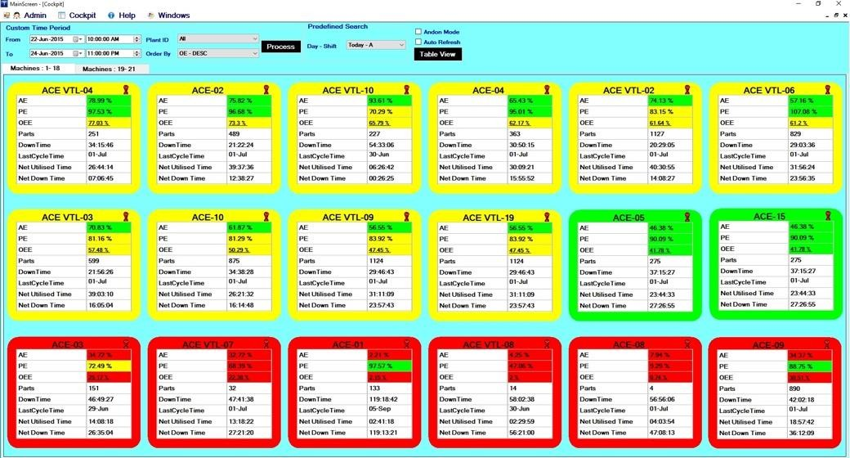

5S POLICY

5S aim is to improve the work place environment by using *5’s’ technique*

Which is a systematic and traditional approach to work place organization and

Methodical house keeping with a sense of purpose, consisting of the following

Five elements.

SEIRI: Sorting

SEITON: Systematic arrangement

SEISO: Spic & Span

SEIKETSU: Standardization

SHITSUKE: Self Discipline

*SEIRI :( Sorting)*

* Segregate required, usable, rework able and obsolete items or materials.
* Dispose of unwanted items
* *Clear off walkways.*

*SEITON* :( Systematic Arrangement)

* Use labels, color codes for easy identification.
* Use index for files, records, drawings etc. to facilitate irretrievability.
* Plan storage with accessibility.

*SEISO*: (Shining)

* Inspect and clean the supply lines, god owns, scrap yards and gardens.
* Clean up work place, machines and tools after use.
* Identify root causes of loud noise, vibration, heat buildup in equipment and take remedial action.

*SEIKETSU* :( Standardization)

* Develop Standards.

Establish checking procedure.

* Create visual controls.
* Device ways and means to expose problems.

*SHITSUKHE:* (Self Discipline)

* Develop action plan for maintaining the set standards.
* Give unambiguous advice/instruction to your work associations.
* Carry on 5s activities as a matter of habit and enthuse other to practice 5s.
* Conduct Self Audit.

SAFETY

In Amara raja group of companies, safety is defined as the 6th ‘S’, which is considered as the most important one. Each and every employee must ensure safety before the work is done. They provide PPE for every employee, which are required with respect to their allotted work.

PPE (Personal Protective Equipment’s):

When PPE is essential?

When hazards cannot be eliminated through engineering and /or

Administrative controls, PPE must be used to protect the eyes, face, hands,

Foot, arms, body, ears and lungs.

Personal Protective Equipment:

* Goggles
* Ear plugs
* Hand Glows
* Respirator
* Apron
* Safety Shoes
* Helmet

PPE means Personal Protection Equipment.

PPE comprises of the following, namely

1) Gloves-used to protect hands at working places like tinning, lamination cutting etc.

2) Goggles-used to protect eyes at working places like tinning, welding, etc,.

3) Respiratory-used to resist harmful gases &smell entering nose at soldering, tinning, impregnation etc.

4) Ear plugs used to protect our ears from loud noise which produce loud noise

5) Safety shoes-these are the important safety equipment, which protects legs where heavy work is done.

6) Apron-used to protect body at work places like soldering, welding etc.

In Amara raja, they also define BBS as the most important factor that ensure safety of an employee.

BBS stands for Behavior Based Safety.

BBS says that, safety is not only provided by equipment, but also depends on the behavior of person

BBS involves

* -identifying person working with unsafe behavior
* -making them sure to work safely, by ensuring the following,
* -proper handling of tools
* -no usage of mobiles while working etc.